Employee Travel Claim Reimbursement Instructions

Note: All original receipts must be electronically attached to support expense claim items.
Receipts and supporting documents are uploaded/attached to an expense report by clicking the “Attachments” link in the expense report. Attachments include supporting documents that have been received in electronic format or original paper documents that can be scanned and saved as PDF documents. Pictures of receipts are also acceptable. Once documents are uploaded and the claim is submitted, claimants can email the finance administrator letting them know the claim number and that it has been submitted. Original paper receipts do not need to be submitted to the unit - the electronic version attached to PeopleSoft becomes the original.

1. Log into PeopleSoft Financials by going to the following Link; https://ist.ualberta.ca/enterprise-applications

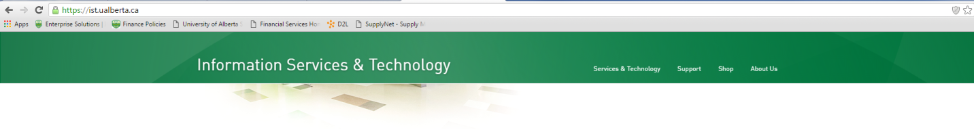
Click on the “Financials” icon.
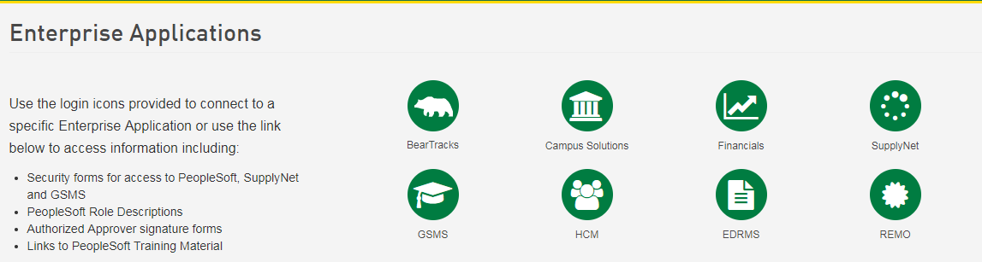
Click on ``Financials``

2. On the main screen, “Self-Service Center” in the area noted as “Travel and Expenses” click on the link labeled “Create Expense Report”.
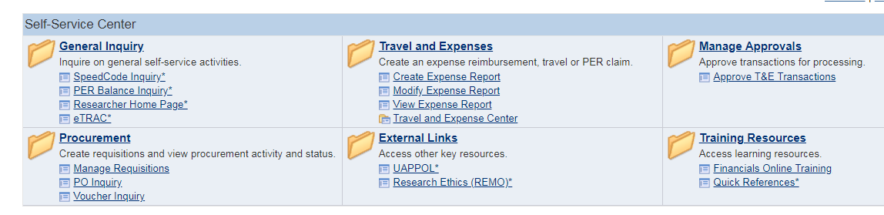
Click on “Create Expense Report”
``

Create - Creates a new report.
Modify - Updates a report that has been saved but not submitted, or was sent back for revisions.
View - Display a report that has been submitted, created, or modified.
Delete - Delete a report that has been saved but not submitted.

3. There are two separate forms for creating an expense report. This demonstration is for Travel Expenses. Click “Select” to choose the form for Travel Expenses.

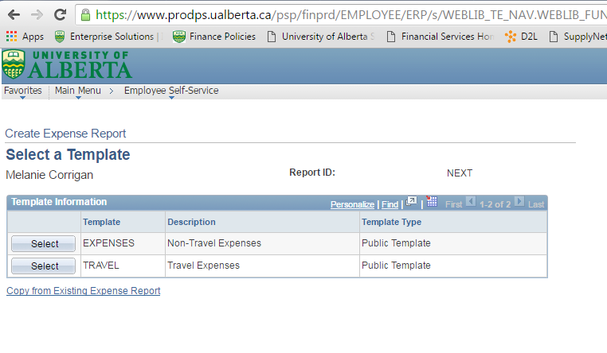
Click on “Select” next to the Travel Expenses

4. Under the Expense Date, you will enter the start date of travel. Note; you will revise that date for specific receipts in the next screen.

This screen also asks you to identify the Expense Types. These should all be related to the particular trip you are claiming. Select all of the applicable expense types that are listed that might be relevant to the expenses you have incurred. If there is not an Expense Type that accurately categorizes your expenses you will select “Services General” or “Supplies General”. Click OK to continue.

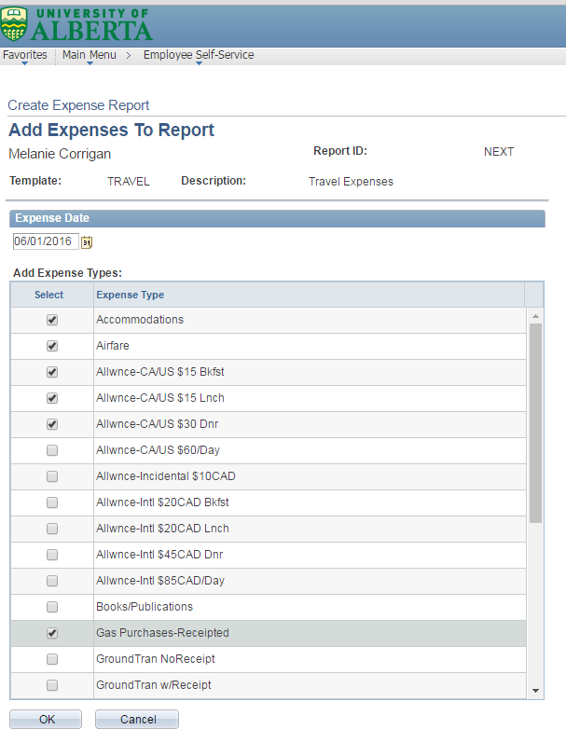
Enter the start date of travel or transaction date.
Select the most appropriate Expense Type for the receipts you are claiming for the Travel Expenses
5. The “Expense Report Entry” screen will pop up. You will need to enter the following information on this report;
- Description;
  - Your description should read: Location – Month Year (ie: AOCS Las Vegas – June 2018).
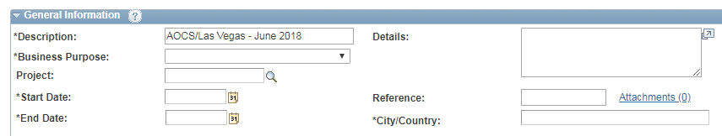

- Business purpose;
  - You will choose an appropriate category based on the reason for the trip.
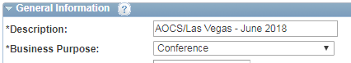
Select the drop down arrow and choose business purpose

- Project;
  - Leave as is.

- Enter the speed code;
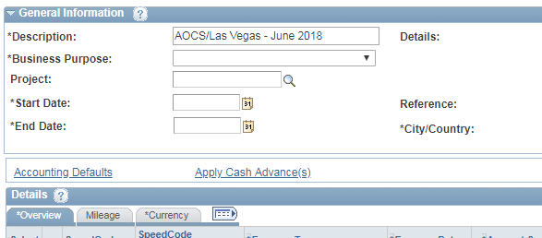
  - Click on the “Accounting Defaults” link.

  - Click ``OK`` to accept the speed code. If you do not enter a speed code, you cannot submit your claim.
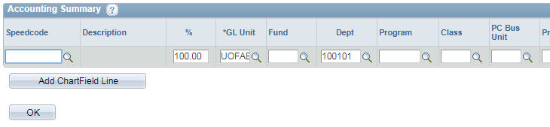

Enter the speedcode that expenses should be charged to. Select “ok”.

  - Note: To change a speed code for a specific line click on the Magnifying glass link on the expense form.

- You will be prompted to enter details supporting the expense claim. Click “Ok”.

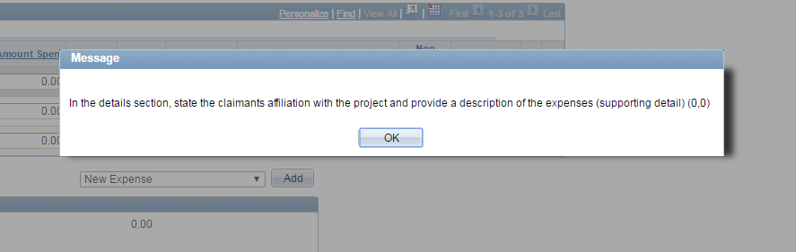
Click OK

- Details;
  - In the ``Details`` section you should provide the following;
    - Project Holder (Field automatically populated – DO NOT CHANGE).
    - Number (Field automatically populated – DO NOT CHANGE).
    - Title (Field automatically populated – DO NOT CHANGE).
    - Add - What was the business activity – Purpose of event.
    - Add - Who was in attendance at the event.
    - Add - Where did the event take place.

  - Note: If the claim is being charged to a project funded by Tri-Agency (NSERC, CIHR, & SSHRC) provide the following;
    - Add - Traveller’s affiliation with the project.
    - Add - Include how travel contributes towards the direct cost of research/activities.

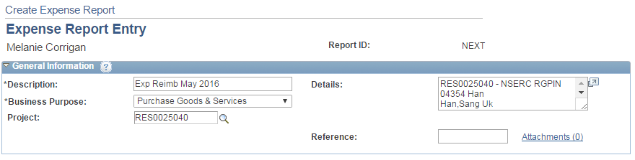
Add comments here that will identify how the expense relates to the grant. Provide as much detail as possible.

- Attachments;
  - This field is used for attachment of receipts. Pictures of receipts, scan copies, and electronic copies must be attached for all items being claimed. Proof of payment must be evident on the attachments (including credit card statements if necessary).

  - You can also use this link to attach mileage reports in Excel or a Word document containing more detail on the trip (not mandatory).

Click on the attachment link to add attachments such as receipts, mileage reports etc.

  - In the next screen click ``Add Attachment`` to choose the file from your computer. A browser will pop up enabling you to do so. Select the file you want to attach by uploading it. Click ``OK``.
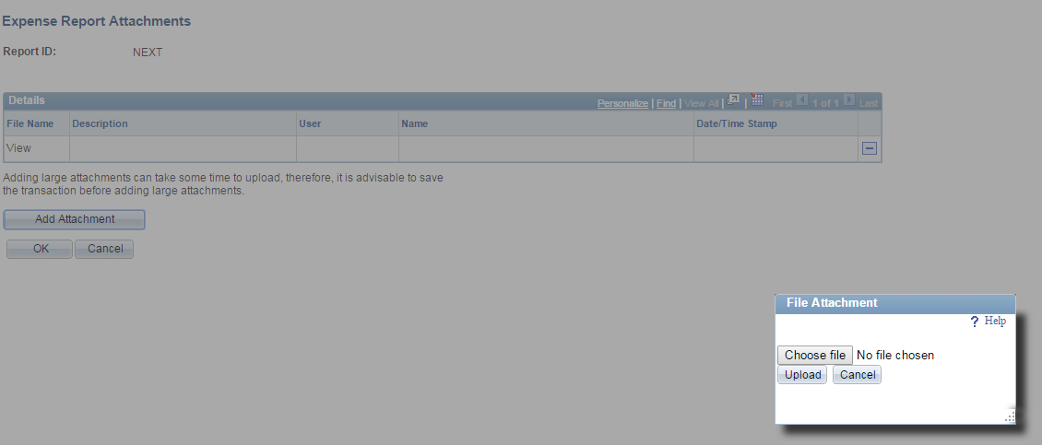
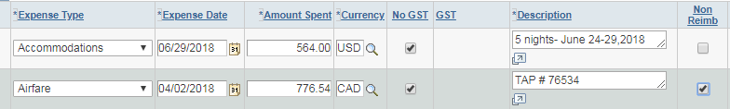
** Note ** Enter all details for your expenses. Include everything related to the trip. This includes items such as TAP, HAP, or Corporate Card charges for registration (or other) that was paid for directly through a speed code. After you enter the item select the NonReimb box.

- Expense Date;
  - Should be changed to match the date on the actual receipt.

- Amount Spent;
  - This amount is the total spent including the GST.
  - You can adjust the amount spent to another currency to match the currency the purchase was made in (ie: USD). Click the icon beside amount spent and select your currency.
** Note ** When expenses are incurred in foreign currency, the following methods may be used to exchange to Canadian dollars (CAD) on the expense claim;
- The actual CAD currency charged on the U of A travel card or a personal credit card statement (a copy of the statement must be attached to the claim).
- The 7-day PeopleSoft average (for currency supported by Peoplesoft – Auto populates).
- No other methods of applying the exchange rate are accepted.
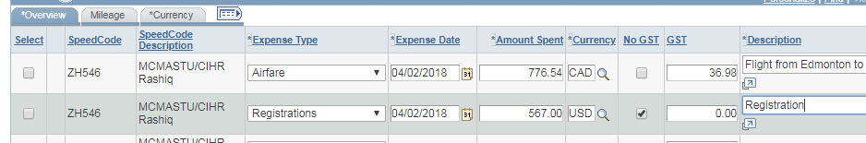

- GST;
  - Will populate once you enter the amount spent. This automatically calculates however if the GST has calculated a different amount than that which is on the actual receipt, you will want to edit the GST amount to reflect the amount identified on the receipt.
  - If there is no GST amount on the receipt, or it is a foreign currency receipt, GST should be 0. Click the “No GST” box.

- Description;
  - This field allows you to add detail surrounding the expenses claimed (ie; Travel to YYC to attend conference).

- Non Reimb;
  - Select this field if the item is not reimbursable because it was paid directly by a speed code.

- No Rcpt;
  - This field is no longer used. Any claims where receipts are not available are non-compliant. Claimants must have receipts for all expenses.

- Kilometers & Mileage Tab;
  - Private automobiles cannot be used for business travel that will exceed 1,000 km round-trip.
  - To claim kms/mileage select the mileage tab and in the kilometers column enter the total number of kms driven. Click the overview tab to return to the expense claim.
  - Travel itinerary is required. Attach a printout from google maps including to and from locations.

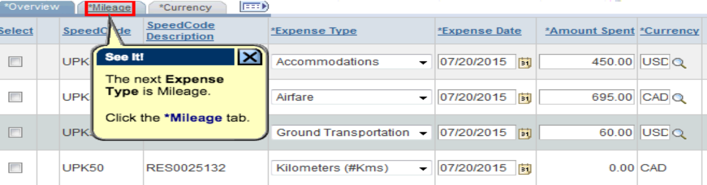
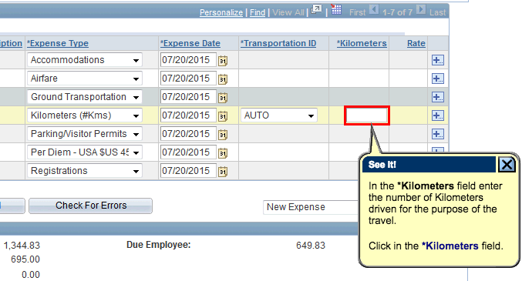

- Applying a Cash Advance;
  - Select the “Apply Cash Advance link.
  - Enter the advance ID #.
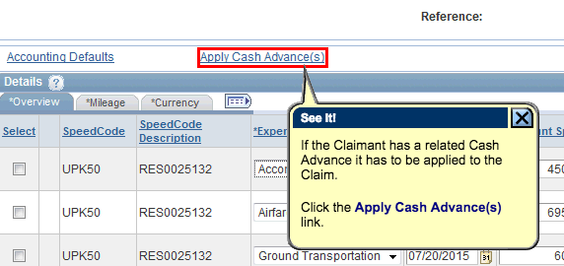
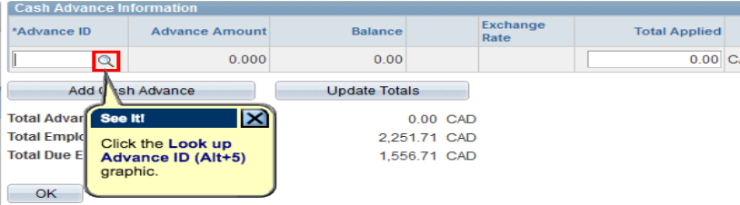
  - Enter the total amount of the cash advance you will apply to this claim in the “Total Applied” field.
  - Click “Ok”.

- Travel Awards (FGSR & GSA);
  - If you have been approved or have received a travel award, attach a copy of the award letter to the claim.
  - Enter all of your expenses onto the claim and for expenses that will be covered by the award, check the “Non Reimb” box.
  - To get the non-reimbursable amount to match the exact award amount you may have to split one receipt amount into two separate lines.
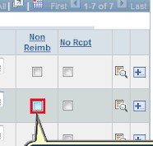

- If you are confident the expense report is complete click “Save”.
  - Once you have saved the report you will want to print a copy off. Select the ``Print Detailed Report`` link in the overview tab. It will pop up in a new window which you will print.

- Once you have a printed copy, click “submit” and then click “Ok”.
  - Email your ALES Finance Administrator to let them know you have submitted expense report # “XXXX”.
  - Check that the status of your claim does not say “pending”. If it does, click “submit” and “ok” again.

Important Notes;

Required Supporting Documents;
- Detailed receipts are required for all travel expenses except in those instances where allowance rates apply.
- Copy of TAP and/or HAP, and Conference registration, where applicable.
- Any expenses related to the trip paid directly by the U of A, are to be included on the claim, indicating that they are non-reimbursable by using the “Non Reimb” checkbox (ie: HAP/TAP).
- Conference, meeting and event agendas.
- For airfare receipts - The fare class booked and travelled must be displayed on the supporting documentation when it is submitted for reimbursement.
- For meetings, collaboration, research and site visits the claimant needs to be specific and attach supporting documentation that answers the four “W’s” (who, what, where and when).
- Proof of payment is also required on the receipts and supporting documents. Receipts must indicate how it was paid (ie: credit card, debit, etc.). If the receipt does not show the payment method, attach a copy of your bank or cc statement (you can block out details not pertinent to the specific purchase). Statement should include your name and last 4 digits of card #.

Entering Receipts on Claims;
- Receipted expenses should not be combined and should each be entered on their own line.
- Meal allowances and incidentals are the only charges that can be combined on one line. Include the dates and meals you are claiming each for in the details section of the claim.

All questions and expense claim inquiries can be directed at your ALES Finance Administrator. Contact information can be found on the following link; https://www.ualberta.ca/agriculture-life-environment-sciences/about-us/for-faculty-and-staff/finance

