Non-Employee - Expense Claim Reimbursement Instructions (Regular and Travel)
Non-Employee Definition: An individual with a temporary business relationship with the University, such as speaking, attending a lecture, meeting, workshop or research collaboration. Non-Employees do not receive employment income from the University nor are they covered under any collective agreements at the university.
Note: Payment to a company, organization, or association cannot be made using this form. The company, organization, or association must issue an invoice with receipts attached to the University.
On the Financial Services site click on the “Forms Cabinet” to locate the expense form for Non-Employees.
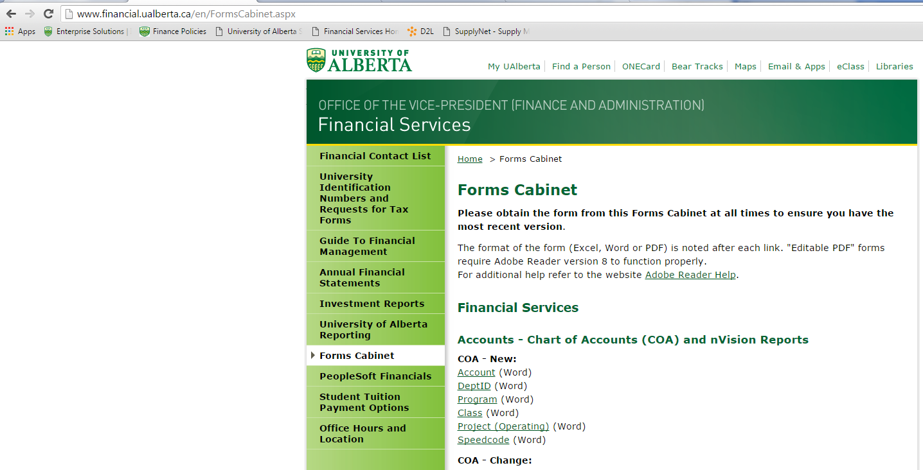
Click on the “Forms Cabinet” link to find the expense form for Non-Employees.
On the right side, the forms list will appear. Scroll down until you locate the “Travel and Expense Management” section.
Click on the link to the form for “Non-Employee Travel Expense Payment”.
Click on the “Non-Employee Travel Expense Payment” link.

Once you have selected the link your browser will bring up a new page with the form on it. There is a detailed set of instructions included on page 2 of the form.
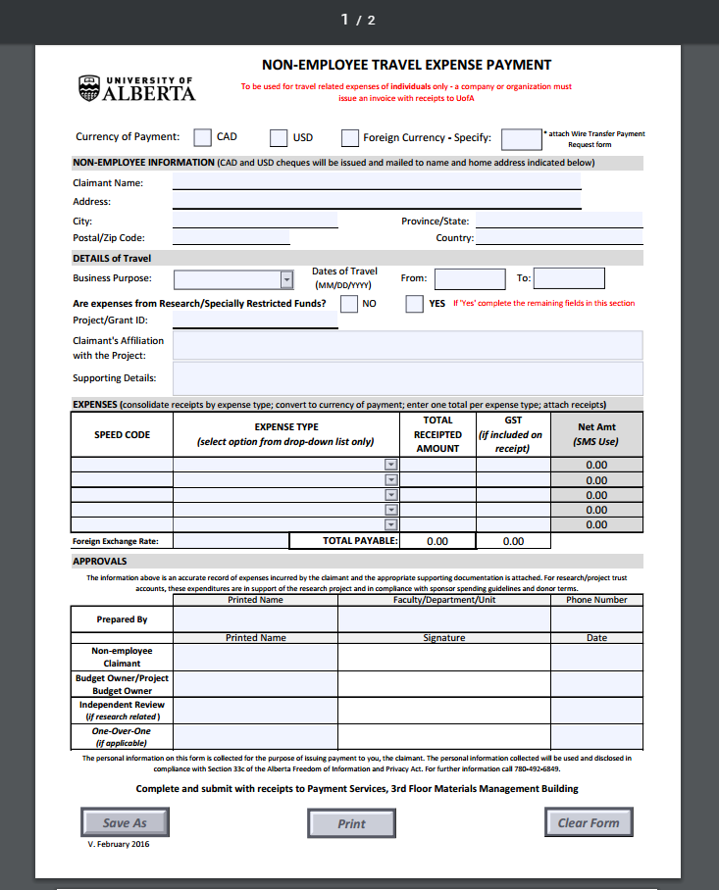

The following fields must be completed if applicable;
- Currency of payment ;

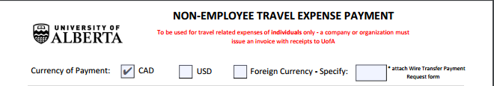

- Attach Wire Transfer Payment Request Form; Claimants to be paid in foreign currencies must provide their banking details by attaching the Wire Transfer Payment Request form found on the SMS forms cabinet.

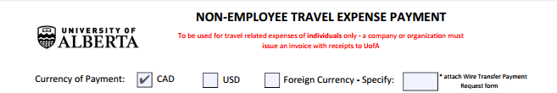

- Non-Employee Information; Non-employee’s full name and home address must be completed. This information is used to issue and mail payment. Do not use the host department’s campus address.

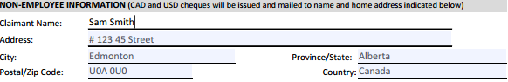

- Details of Travel; Select from the drop-down list, the most descriptive business purpose (** Required). Provide the From and To dates of travel (** Required). Supporting details include, but are not limited to, dates, place of travel, and name of conference/event or purpose of meeting.

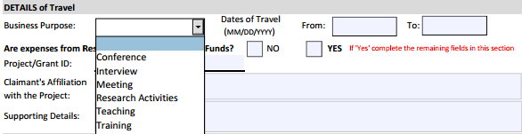
Click on the drop down menu and choose the most appropriate description.

- If research funds are used to expense this travel payment, the Project ID, claimant’s affiliation with the project and supporting details, are (** Required).
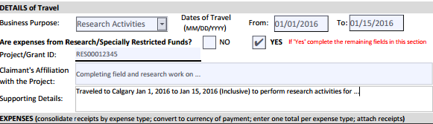
- Under the Expenses section you will enter the Speed Code that applies to the expenses incurred, expense type (using the drop-down menu), the total amount on the receipt, and the GST amount on the receipt (If there is no apparent GST amount – leave blank).

- NOTE: Reimbursement for the purchase of goods and services must not exceed $ 500 per receipt.

- Note: In order to process reimbursement, a detailed receipt is required with the exception of meal or km allowance, meter parking & ground transportation under $ 75.
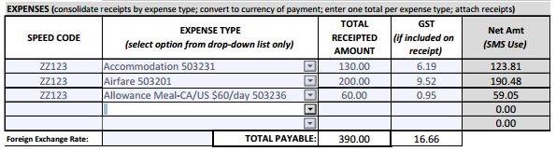
These fields will automatically calculate and update once the total receipted and GST amounts are entered.

- The form must be signed by the Non-Employee claimant, or if the claimant is no longer available, a signed letter or e-mail accompanying the form is acceptable. See page 2 of the Form for further detail on approval levels.
- If original copies of receipts cannot be obtained, scanned copies or pictures will be sufficient. Originals are preferred.
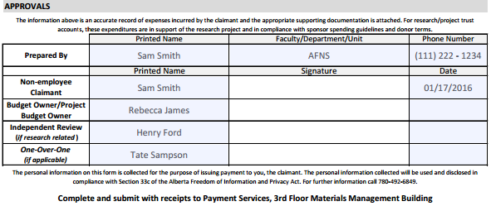
Sam Smith
- Save and print the form and forward to the Budget Owner or PI to be approved and forward to the ALES Finance team for payment processing.
For more information about how to complete Non-Employee expense claims, see page 2 of the form.

