Approving Time
This Quick Reference Guide provides the basics for approving time after it has been reviewed by a Timekeeper and is ready to be approved by you. This guide is not a comprehensive reference of all scenarios you may see. If you have questions or need further information, please contact your Department HR Contact or Timekeeper.

Create a Desktop Shortcut to PeopleSoft HCM – One Time Setup Only
A Job Aid has been provided containing detailed steps on how to create a Desktop Shortcut to PeopleSoft HCM.

Sign-in to PeopleSoft - Then its 6 Clicks to Approval Success
FIRST, a Time Auditor/Timekeeper must review the Employee’s Payable Time before you follow these steps.
- Click on your PeopleSoft HCM Desktop Shortcut

- Sign into PeopleSoft HCM
- Click on Time & Labor WorkCenter Link within your Manager Dashboard | 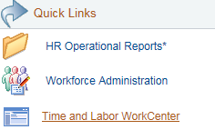
- Click Pending Payable Time | 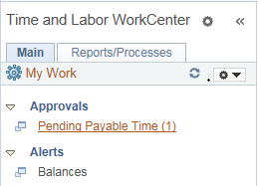
- Click Select All
- Click Approve
- Click Yes to confirm and complete the approval
- Close out of PeopleSoft HCM
Helpful Hints
- Time Administration runs at Noon and 7 pm Monday – Friday. The ability to approve hours submitted by your employee is dependent upon Time Administration run times and when the time entered was submitted to you for approval.

- Leave yourself time to approve Payable Time.

- Know your Approval Cut-off Times. Check with your Department HR Contact or Timekeeper to confirm.

- Below are examples of Time Entry and Approval timing:
Example 1:

Step 1: Employee enters time on timesheet at the end of their shift – 4:30 pm
Step 2: Time Administration run – 7:00 pm
Step 3: Pending Payable time will show on your Dashboard – after 8:00 pm*

Example 2:

Step 1: Employee enters time for the previous day – 11:00 am
Step 2: Time Administration run - Noon
Step 3: Pending Payable time will show on your Dashboard – after 1:00 pm*

*Time Administration runs are in a queue with other batch processes which could impact when you actually see Payable Time

IMPORTANT! If you are unsure if the time entered is correct, contact your Timekeeper or Department HR Contact for assistance.

